Pulpit reflection: It's Not Easy Being Green

(Note: you might want to read remarks I made for the 2006 UUSM Pledge Event first.)

Good morning. I'm Tom Newman.

On Friday night when I spoke at the Pledge Event, I mentioned that feeling a connection with the Universe was wonderful but also sometimes painful. For some reason I am either blessed or cursed with that feeling of connection, and it makes me aware of the adverse impact other people and I are having on the environment and makes me want to reduce that impact.

Although, by world standards, I am still a huge pig, I have made some changes and want to make more. I try to minimize my driving by using public transportation or my bicycle and by sharing rides. This sometimes involves risking being annoying by asking my friends for rides. In fact, I'm looking for a ride home to San Carlos after the Green Faire -- let me know if you can help me out! Or, if you are leaving sooner, maybe you can give Johannah a ride.

I try to reduce energy use at home by turning off lights and turning down the heat, to the frequent annoyance of Johannah, who likes it bright and warm. I remember one morning explaining to my then teen-aged daughter Rosie how her leaving lights on bothers me because it contributes to global warming, which has caused flooding in Bangladesh, and epidemics of diarrhea there that have killed many children. Rosie was not impressed by the strength of that causal chain, and wondered whether I might instead see a connection between me talking about diarrhea while she was eating breakfast and her getting up and eating in the other room. The sad fact is, I really do perceive the sort of connections I mentioned to her. And I am hoping that in this community we can challenge each other to make dramatic changes in how we live, so that we can live more consistently with those connections.

The other thing I spoke about Friday evening was our effort to improve signs on the approach to the Hayward-San Mateo Bridge, to reduce the global warming (and diarrheal disease in Bangladesh) that happens as a result of unintended trips to Hayward. I got such a nice response that I thought I would share a little more of the story.

For those who weren't there, I read part of my 10th letter to Robert Haus of CalTrans, which was in December, 2004. He did not respond to that letter, nor to my Easter greetings in March of 2005. Here is an excerpt of a letter I wrote August 9, 2005:

Dear Mr. Haus,
I know ours has been a rather one-sided correspondence, but I
wanted to share with you something that happened to me Saturday. I'm
currently on an airplane returning from Washington DC, where I attended an
NIH meeting to review grant proposals about a kidney disease in
children. I probably ought to be working, rather than writing you this
letter, but lately the line between my personal efforts to make the world a
better place and my job have become blurred, as I have decided that, as a
pediatrician interested in public health and a big-shot medical school
professor, part of what I need to do now is to try to rid the world of
nuclear weapons.
It was with that goal in mind that I planned to attend a
demonstration in Livermore last Saturday. As you may know, Saturday was the 60th anniversary of the dropping of an atomic bomb on Hiroshima. Since the Livermore Lab is in the business of designing nuclear weapons and is a part of the University of California, my beloved employer, I thought it would be good for me to show up at the demonstration protesting the ongoing design of instruments of genocide there.
Being ever concerned about global warming and our county's
dependence on foreign oil, I did not wish to drive to the demonstration
alone, even in my hybrid car. So I went to a ride sharing website and
found a ride. I arranged with "Turtle-Jean" to pick me up at the Costco
in Foster City...
Guess what happened? Jean called me from the San Mateo Bridge. She had accidentally missed the exit and was on her way to Hayward... She offered to wait for me [there], but I decided the ecological cost of a round trip to Hayward was too high, so I skipped the demonstration. This was not all bad -- I ended up being able to have dinner with my wife, who had been upset at me for going to the demonstration, because she feels like I spend too much time on this stuff.
And, I thought, maybe in the grand scheme of things I could
better spend that time writing you a letter about my mishap, and have you
find the story so touching that you would be moved to improve the signage,
and help us advance towards energy independence and ecologic
sustainability, or at least towards that still elusive goal, "Every Trip to
Hayward a Wanted Trip to Hayward."
How about it?
With warmest personal regards to you and your family,
Thomas B. Newman, MD, MPH
Professor of Epidemiology and Biostatistics and Pediatrics, UCSF
Member, Social Action Committee, Unitarian Universalists of
San Mateo
Steering Committee, San Francisco Bay Area Physicians for
Social Responsibility
I got no response from Mr. Haus, but I did get a response from Brian Perkins of State Senator Jackie Speier's office, to whom I had been cc-ing my correspondence to Mr. Haus for the previous 2.7 years. As it happened, shortly after my Hiroshima Day letter, a new staff person for Jackie Speier was late for an important meeting in Foster City because she had made an unwanted trip to Hayward. That made Jackie angry with the foot-dragging at Caltrans, and I think that's how we ended up getting our signs.

Who knows? Maybe they'll save some children in Bangladesh.

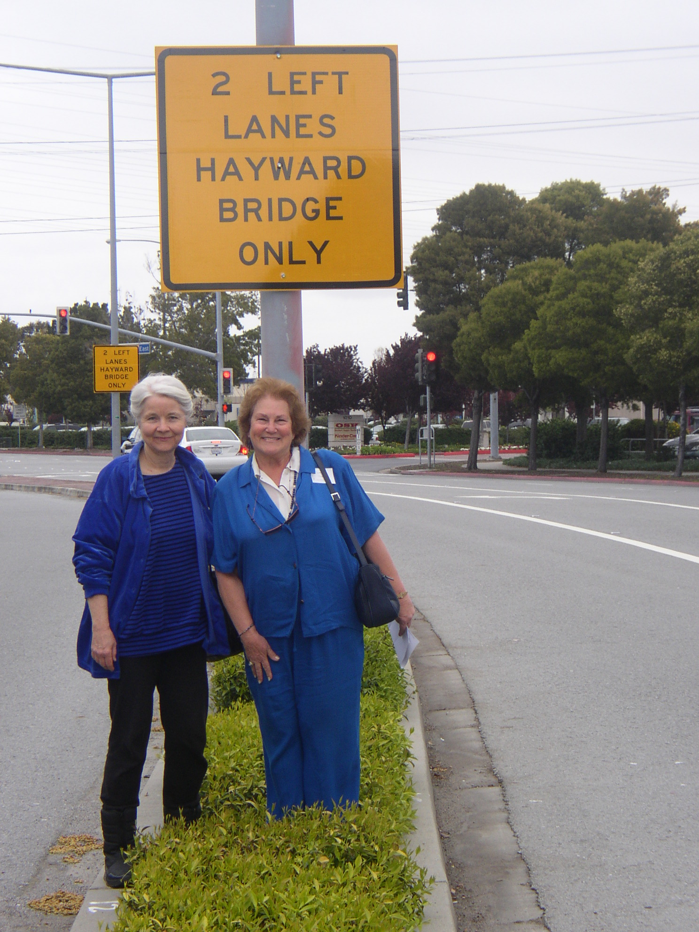

UUSM Social Action Committee Members Maribeth Hulsey and Linda Heath under one of the signs near Costco in Foster City

